DIABETIS TRACKING SYSTEM

ABSTRACT

This Diabetes Tracking System Project is a project that seeks to provide an efficient and effective way to manage user diets and meals intake intended to control the risk of diabetes. The project will focus on creating a system that can collect and analyze data from user on their diabetes management, lifestyle changes, and health outcomes. The project aims to help users better manage their diabetes and improve their overall health. It will also provide healthcare providers with a better understanding of their user needs and provide them with the tools they need to provide the best care possible.

PROJECT OBJECTIVES

* Enable users to register into the system
* Enable users to track their daily meals intake
* Provide secure authentication and security for user’s data
* Enable users to plan their daily meals.

DESIGN GOALS

* Provide an intuitive, user-friendly interface for users to easily enter and track health data.
* Develop a secure and reliable system that protects user data.
* Design a system that can be accessed through different devices, such as computers, tablets, and smartphones.
* Develop features that allow users to access their data easily and quickly.

QUESTIONS

* How can the system be designed to provide an intuitive and user-friendly interface for users to easily enter and track health data?
* What measures can be taken to ensure the security and reliability of the system?
* How can the system be designed to be accessible through different devices?
* How can the system be designed to allow users to access their data easily and quickly?

MAIN TASKS

* Analyze user needs and requirements to determine how to best design the system.
* Design an interface that is intuitive and user-friendly for users to easily enter and track their health data.
* Develop a secure and reliable system that protects user data.
* Create features that allow users to access their data easily and quickly.
* Design features that enable users to easily share their data with their healthcare providers.
* Develop a system that allows healthcare providers to easily access and monitor their patient's data.

CONCEPTUAL MODEL

The conceptual model for the Diabetes Tracking System Project is to create a system that collects and analyzes data from patients on their diabetes management, lifestyle changes, and health outcomes. The mental model for the project is that patient data should be organized and accessible, so that patients and healthcare providers can easily access, monitor, and analyze the data. The model should also facilitate communication between patients and healthcare providers to ensure that the patient is receiving the best possible care.

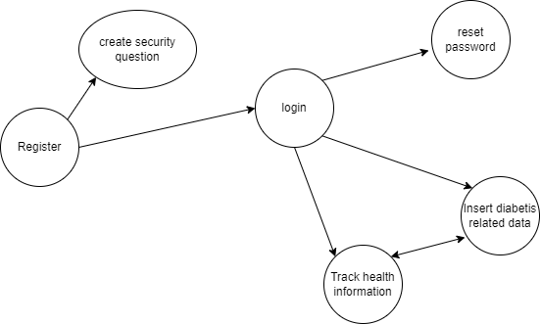

DESIGN

The design idea for the programming component of the Diabetes Tracking System Project is to create a system that collects and analyzes patient data. The system should be secure and reliable, and should be able to be accessed through different devices.

The design considerations for the programming component of the project include creating a secure and reliable system, designing an intuitive user interface, and developing features that allow users to easily access their data. The design considerations include creating an intuitive and user-friendly interface, designing features that allow users to access their data easily and quickly, and developing features that provide personalized feedback and recommendations based on user data.

Figure: Register new user. This is where the user has to create their account which will be used for logging in.

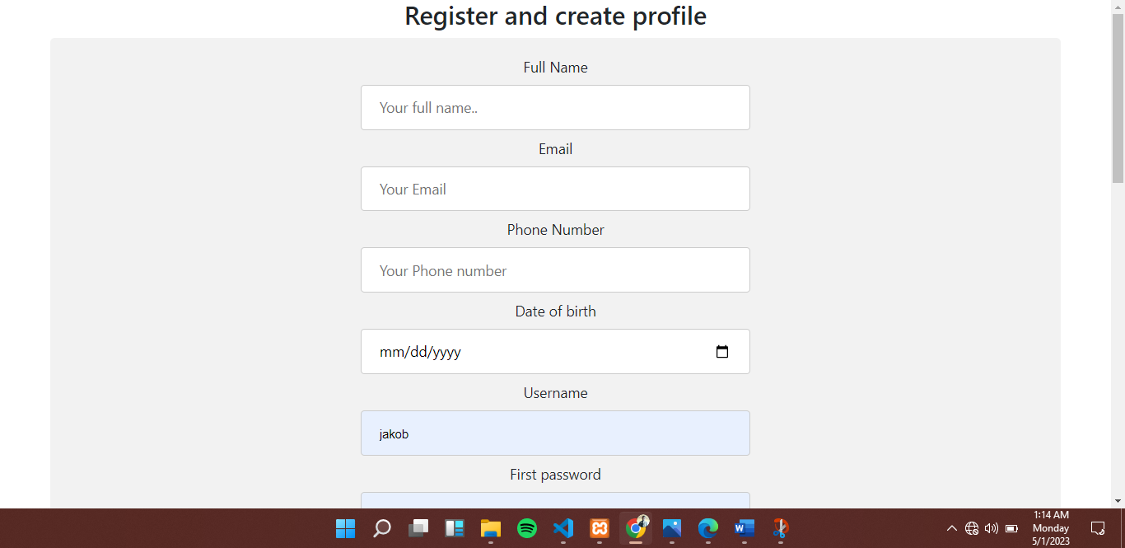

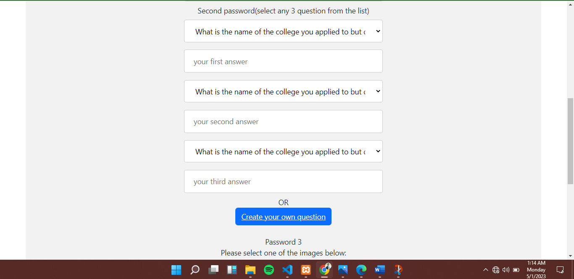

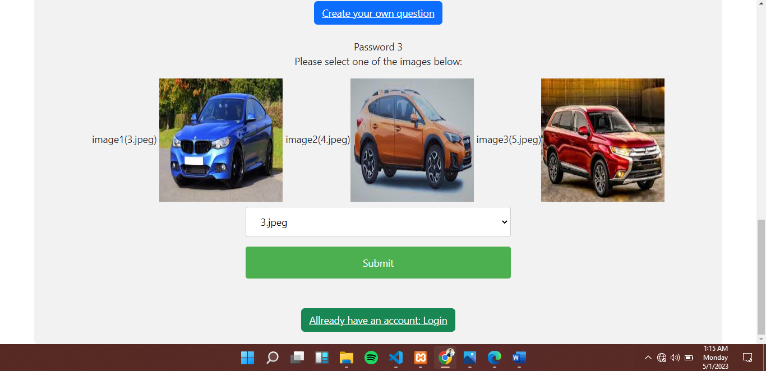

First password must have more than 8 characters and should be a combination of bboth numbers, letters and symbols both uppercase and lowercase.

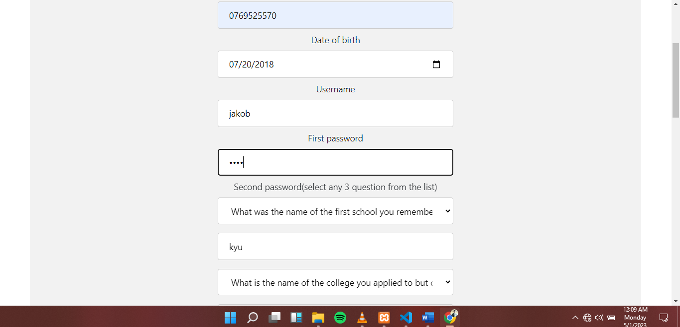

The second password, user has to select from a list of questions then answer them. These answer would be used during login.

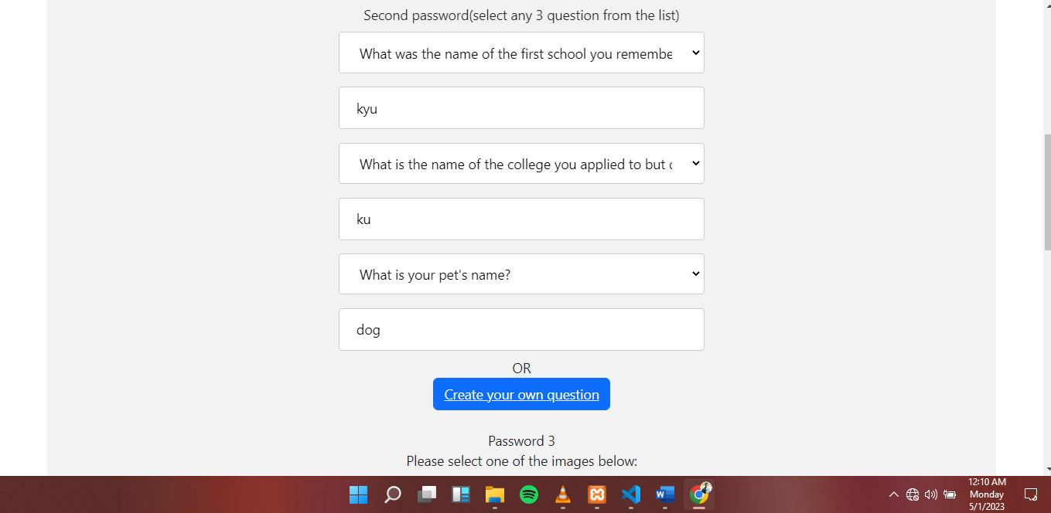

The third password, the user has to select one image from the 3 images which he can use as their password:

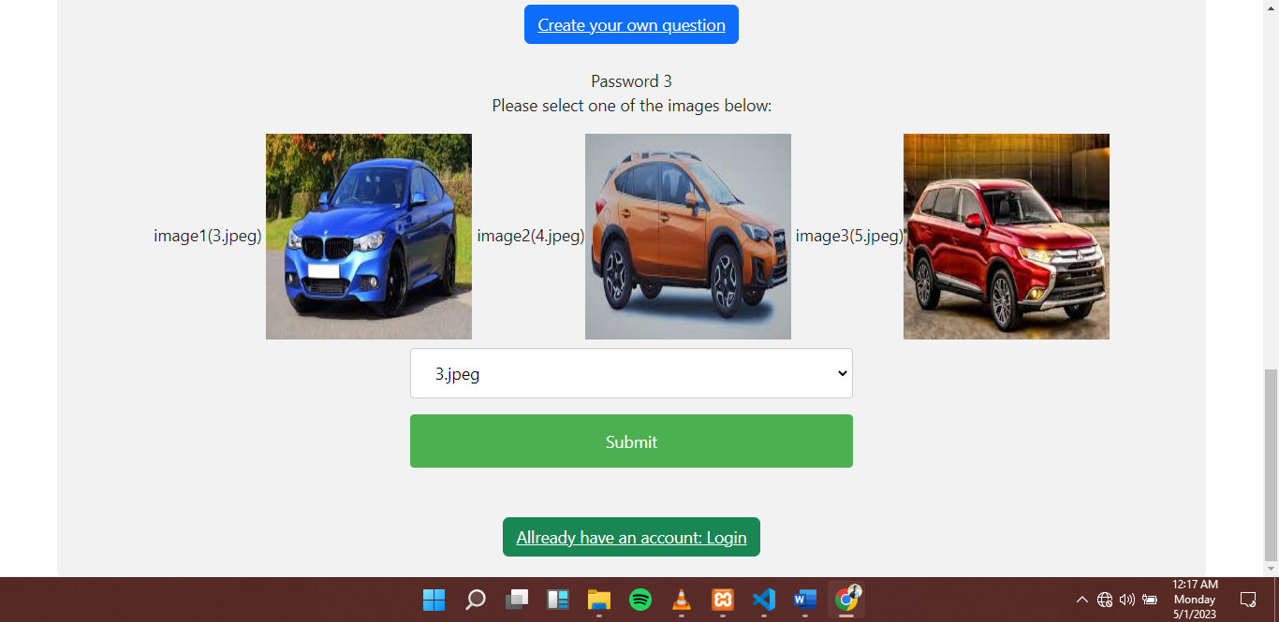

Figure: For the case of password two security questions, the user can decide to create his own security question and provide answers which they will remember easily.

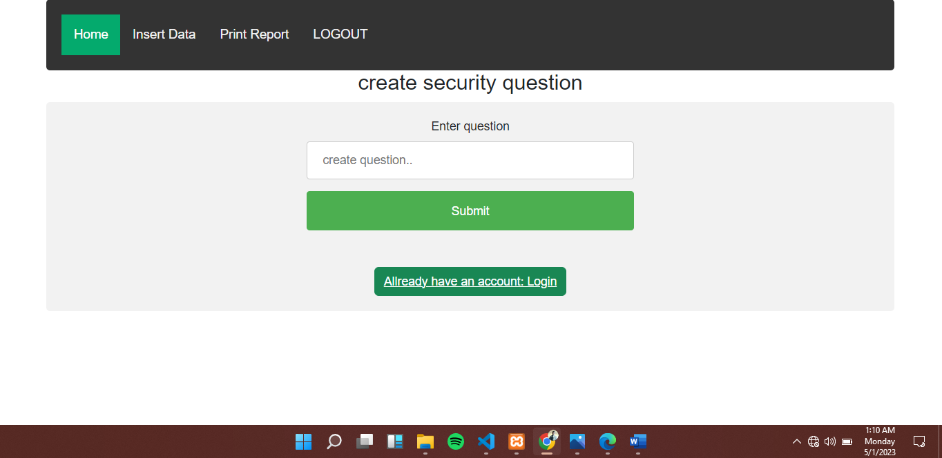

Figure: Login. This section allows user to login using the 3 passwords he created during time of creating account.

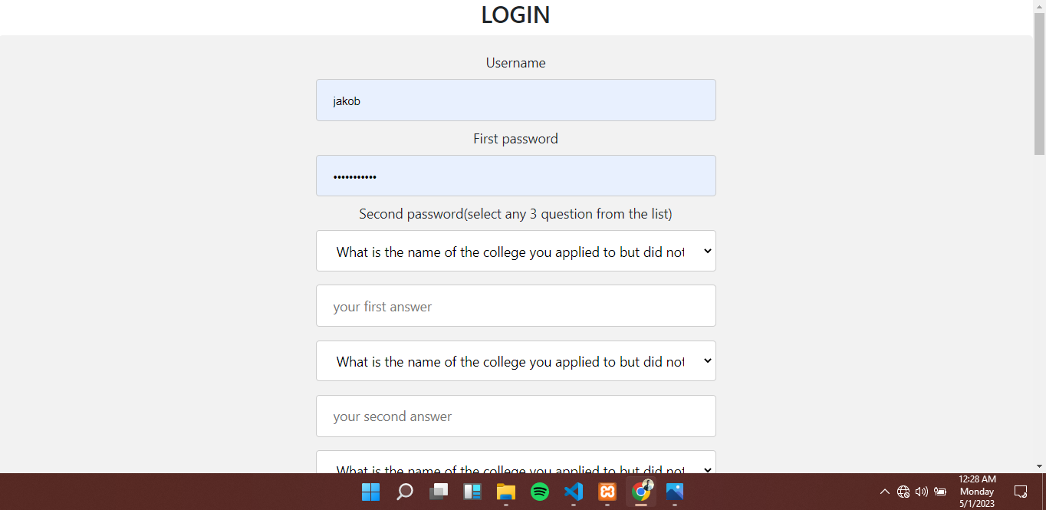

All the three passwords will be used by the user during login. For image password, the user can select one image to use.

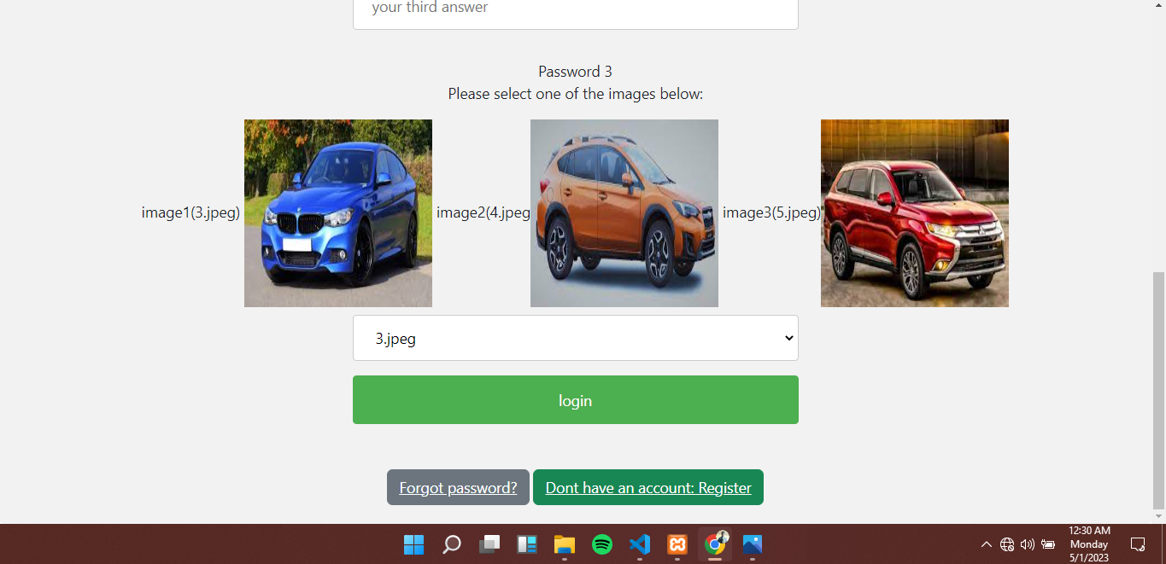

Figure: Forgot password: When the user cant remember their password, they will have to request it through email. The user will submit their email request then an email will be sent to them with a password which they can use to login.

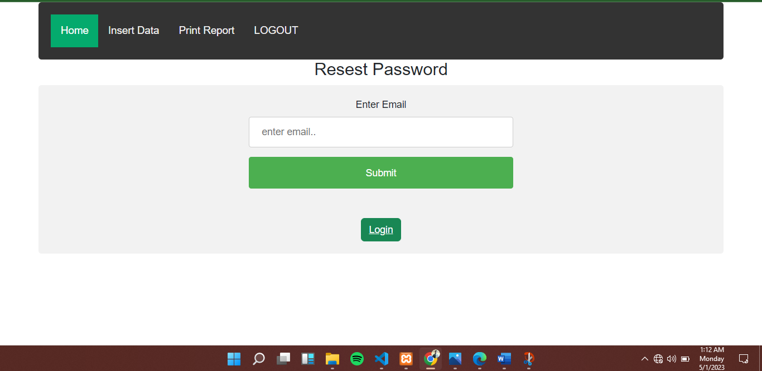

Figure: Fill out the diabetis form for the daily meals intake and blood level before breakfast and 2 hours after dinner

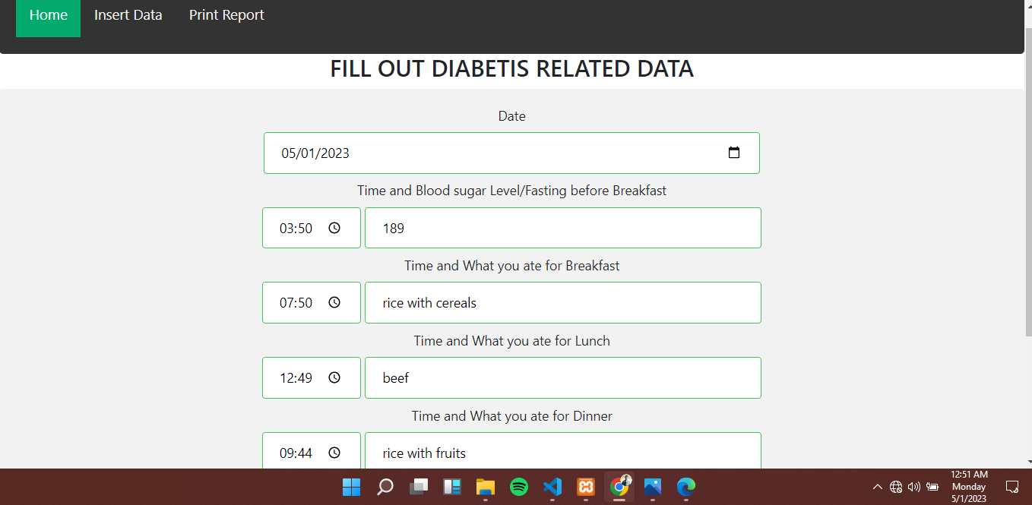

Figure: Print user report. This table displays a report for user details filled out each day. This report will be used to analyze your diabetis status and give insight on what to eat and what not to eat.

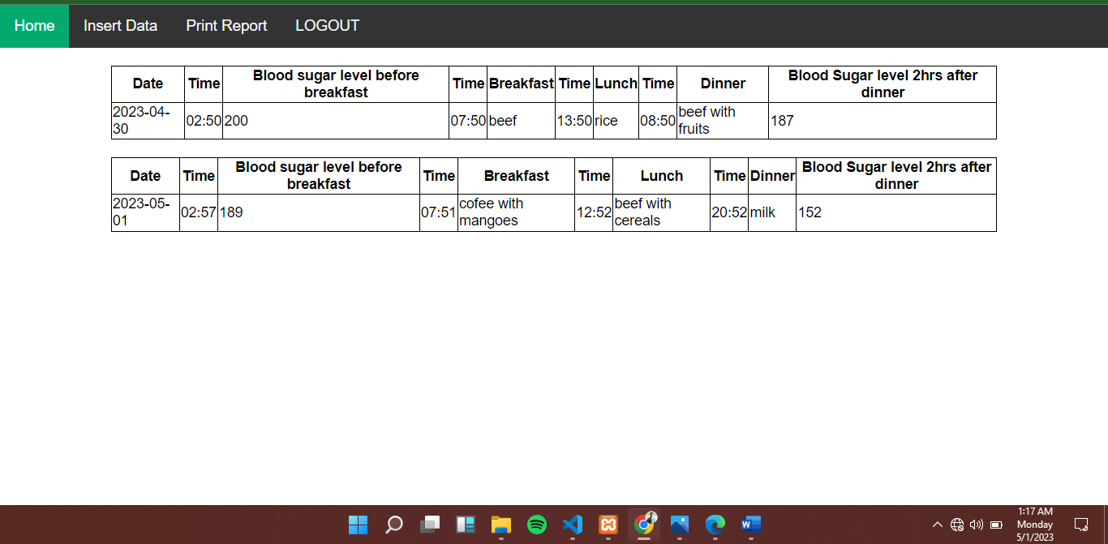

Figure: Database design

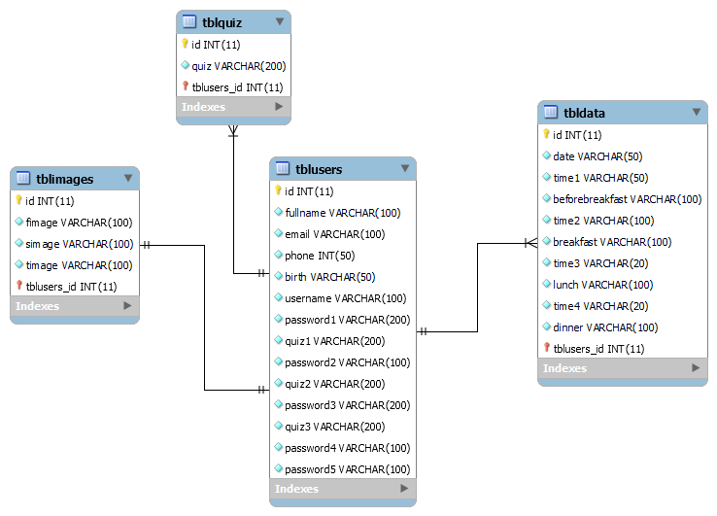

Design Issues:

The design issues for the programming component of the project include ensuring data security and reliability, designing an intuitive user interface, and developing features that allow users to easily access their data.

Design Idea:

The design idea for the interface component of the Diabetes Tracking System Project is to create an intuitive and user-friendly interface that allows users to easily enter and track their health data.

FUNCTIONALITIES

The Diabetes Tracking System Project will provide a variety of functionalities to help patients better manage their diabetes and improve their overall health.

* The system will provide the ability to collect and analyze data from users on their lifestyle, health changes, and health outcomes.
* The system will also allow users to easily share their data with their healthcare providers, and healthcare providers will be able to access and monitor their patient's data.
* The system will be cost-effective and easy to maintain.

TOOLS

The programming languages used to implement the Diabetes Tracking System Project include PHP and PDO(PHP Data Objects). The project was developed using a variety of software and tools, including a XAMPP localhost web server, an MYSQL database management system, Visual Studio Code HTML and CSS editor, and a version control system. The project was also tested on a variety of devices, including desktop computers, laptops, tablets, and smartphones. The Chrome developer tools were also used to test the system and ensure its functionalities.